**Lab 10: Room Database**

**GIới thiệu:**

**Các bước thực hiện:**

**Tạo ứng dụng với Room Database như sau:**

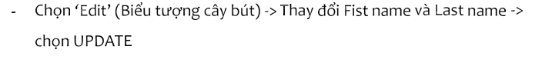

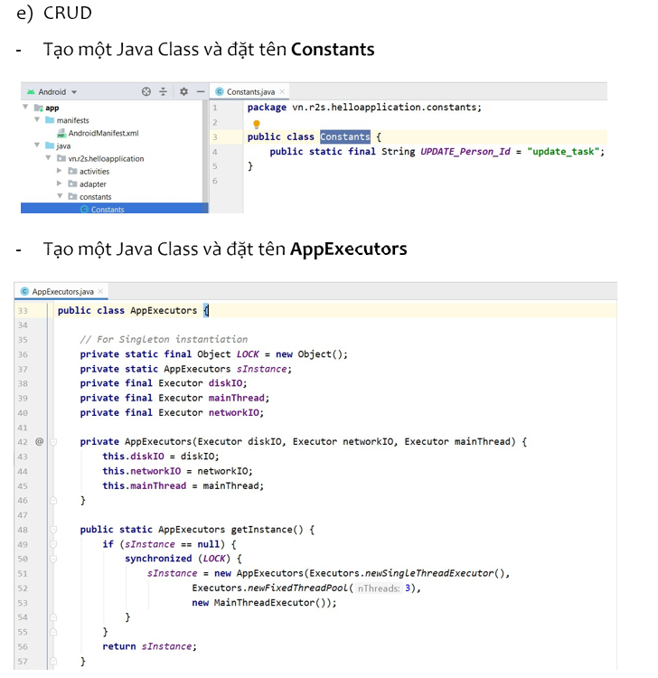

**Chạy ứng dụng**

